

<Thesis Title>

<First Name – Last Name>

Submitted in partial fulfillment of the requirements for  
the Master’s Degree in the Faculty of Engineering  
Bar Ilan University

Ramat-Gan, Israel <Month-Year>

This Work was carried out under the supervision of

<MSc Adviser>

Faculty of Engineering

Bar-Ilan University

Acknowledgements

*This is where you should thank your thesis advisor, your fellow students, who worked on the projects with you and were a big part of your studies, your family, and whoever else you want. You should also point out any funding agencies that contributed through scholarships or grants that funded the work.*

Table of Contents

Chapter 1: Introduction 8

Chapter 2: Background 9

Chapter 3: Thesis Content 10

Chapter 4: Thesis Content – *another contribution* 11

Chapter 5: Thesis Content – *e.g., results* 12

Chapter 6: Summary and Conclusions 13

Appendix A: First Appendix 15

List of Figures

Figure ‎2.1: My first figure. Use the INSERT CAPTION feature to create the automatically numbered caption 9

List of Tables

Table ‎3.1: This is a table caption. 10

Abstract

*The abstract for a thesis or research proposal is much more extensive than the short abstract for an article. It should be approximately 1 page long and really be an executive summary of the proposal, including some background, presenting the problem, and explaining how you propose to address it. Don’t forget to point out your*

*achievements, such as the number of papers that you published.*

# 

# Introduction

*This is the introduction chapter. The introduction is generally an “executive summary”*

*of the thesis, providing some motivation, short overview of state-of-the-art, introduction of the solution presented in the thesis, and some results. It then usually will introduce the structure of the thesis (i.e., the content of each chapter). Make sure to (yet again) point out your achievements, such as papers that have already been published or are in submission.*

# Background

*This is the background chapter. The background chapter should be a very extensive literature survey, covering the main concepts that lead to the presented work and then a detailed overview of the state-of-the-art. Make sure to cover all seminal works that are related to your work and all recent publications. If possible, try to point out limitations or drawbacks of prior art that has led to the work that you are presenting in this thesis.*

*Here is an example of how to include a figure in your thesis. Make sure to reference each and every figure using MSWord’s CROSS REFERENCE feature (e.g.,* see Figure ‎2.1 *) and to provide a sufficient description of the figure contents in both the text and the figure caption.*

*To learn how to make article-quality figures with power point, we recommend watching*

*the following tutorial:*

<https://www.youtube.com/playlist?list=PLZU5hLL_713zNceifg18xNroxzeIBdJi0>.

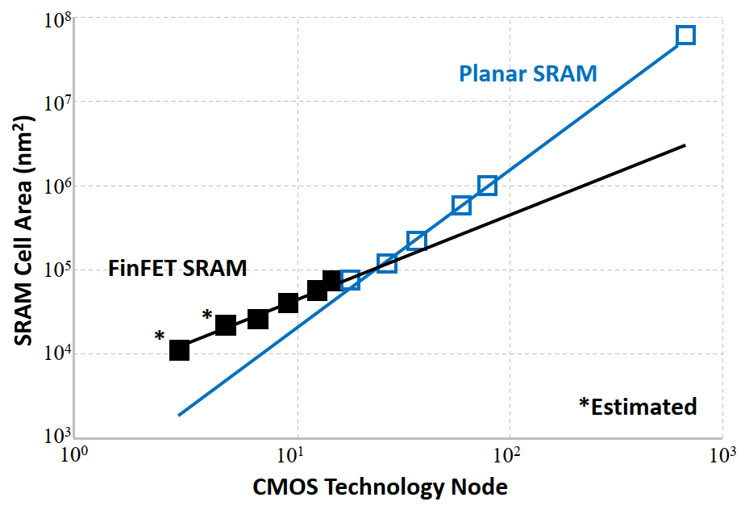

Figure .: My first figure. Use the INSERT CAPTION feature to create the automatically numbered caption

# Thesis Content

*From this chapter and on, you should present the content of your thesis. You will probably have several chapters of content – for example, a chapter for each contribution/published paper.*

*Similar to Figures, you should also reference every Table that you include in the thesis and do this using the CROSS REFERENCE features (e.g.,* see Table ‎3.1*). For a very good tutorial on how to make professional looking tables, see the following presentation:* <https://people.inf.ethz.ch/markusp/teaching/guides/guide-tables.pdf>

|  |  |  |  |
| --- | --- | --- | --- |
| sdfs | First work | Second work | Third work |
| First metric | 100 | 100 | 100 |
| Second metric | 200 | 200 | 200 |
| Third metric | 300 | 300 | 300 |

Table .: This is a table caption.

# Thesis Content – *another contribution*

*This could be a chapter about another contribution of your thesis.*

# Thesis Content – *e.g., results*

*This could be a chapter about the results*

# Summary and Conclusions

## Thesis Summary

*Here you should conclude your work and don’t forget to again emphasize your achievements (e.g., publications).*

## Future Work

*Here you should discuss future steps to build on top of your work.*

Bibliography

1. First Appendix

*OPTIONAL: If you require an appendix (e.g., for attaching a paper or attaching a piece of code) you can add it here.*

תקציר בעברית

*לכתוב פה תקציר לעבודה.*

*לוודא שהתקציר בעברית תואם את התקציר באנגלית!*

*להקפיד לסיים עם הישגי התיזה (למשלכמה מאמרים פורסמו על סמך המחקר)*

עבודה זו נעשתה בהדרכתו/ה של <שם המנחה>

מן הפקולטה להנדסה של אוניברסיטת בר-אילן

אוניברסיטת בר אילן

<כותרת העבודה>

**<שם הסטודנט>**

עבודה זו מוגשת כחלק מהדרישות לשם קבלת תואר מוסמך  
בפקולטה להנדסה של אוניברסיטת בר אילן

רמת גן שבט, תשפ"X